LIBRAURY APPLICATION

NAME: LOYO MOSES  
ROLL NUMBER:CP201902C0016

STARTED DATE: 6TH NOVEMBER 2020.

END DATE:14TH DECEMBER 2018.

This project report explains the designing process of BUILDING THE LIBRAURY APPLICATION which is a desktop system, developed using java jdk 8.1.2. and it aims at giving the user’s required functionalities.

I have worked upon this system with a lot of passion, hard work and with a lot of research. Here are the dynamic development tools that I have used to make the software more efficient; jar files to execute the file on any machine.

**ACKNOWLEDGEMENT**

Sincere thanks goes to APTECH E-Project Team for giving us the immense opportunity not only for show casing our opportunities but also giving us a great challenge to thirst for knowledge which has given us wonderful skills. Special thanks to Mr. Felix Brian my Lecturer who gave me the courage, in and out practical approach to handle such challenges thus making the project an ease of success. My friends (students) that I coped up with.

Lastly, special thanks to all my family members, my friends and my Lecturer who have assisted me in making this project lucrative and within the range of time given to me.

PROJECT ANALYSIS

Introduction

We are living in a digital world and we need to simply the means of doing technical work flows.

Information about the system can be found following the correct procedures.

Background

The project was provided to us by APTECH Project team management as the end of semester two project with specific requirements that I included in the problem statement which handed in earlier in March.

Report Layout

User Guide

The libraury application was worked upon after I contacted my local libraury offices and found out the challenges that they were facing and I had to provide the proper solutions as the upgrade.

DEVELOPER’S GUIDE

Data Planning

Through quantitative research and utmost layout design

Data analysis

Through making prototypes and building valuable ideas.

Assessment

Data implementation

SCRREN SHOTS

The splash screen shot seen bellow is the starting point when the system is starting

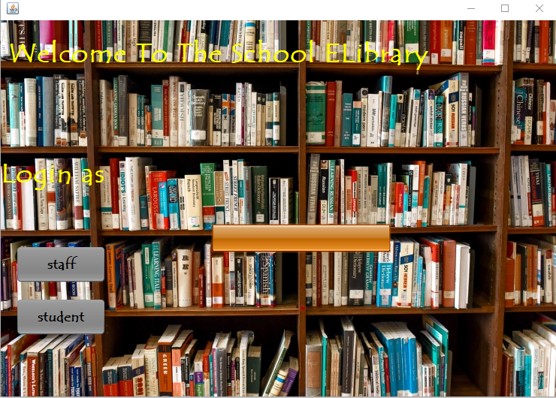

Below is the login page where you can choose either as the admin or user

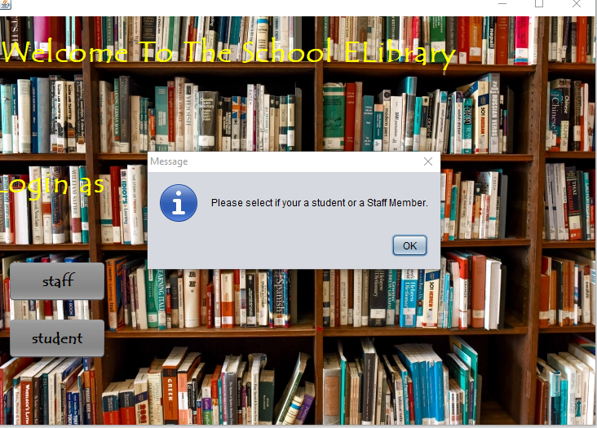

When the admin button is clicked then the admin login panel pops up as seen

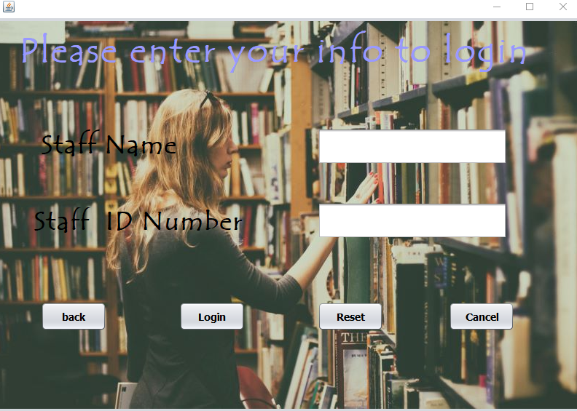

The home admin portal pops up and this where the admin is directed to

navigate

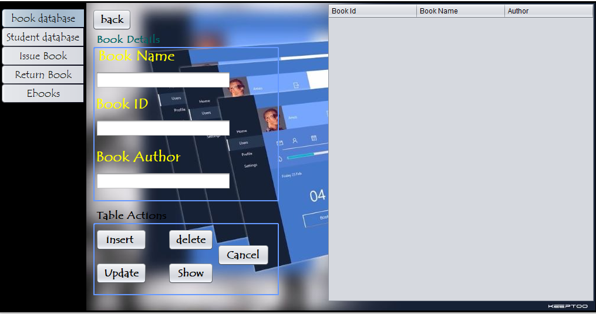

Here is the frame page for the student details. The system is able to add, update delete

records

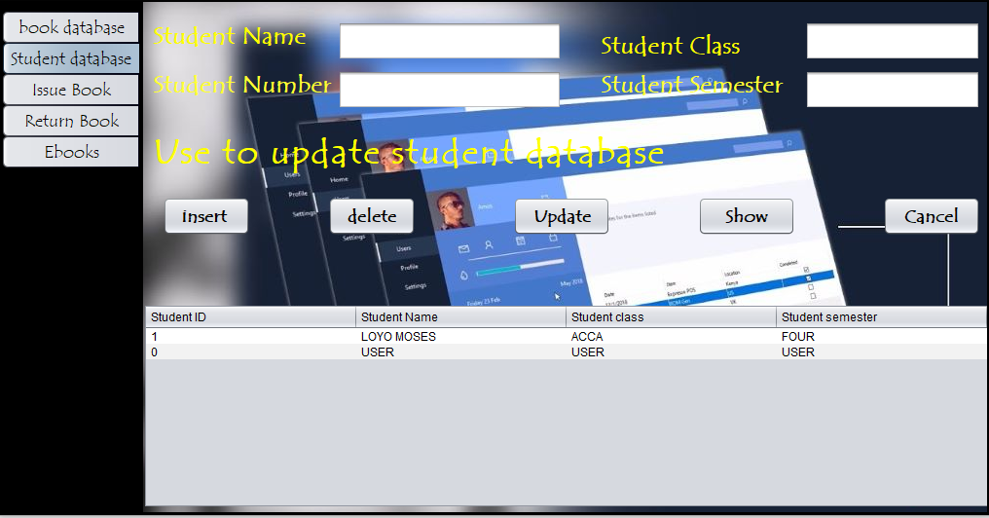

This page shows the information for books in the libraury and all the information required. You can be able to search insert update and delete records



This frame shows how a staff member of the libraury can issue books to students and the students’ details are captured in the database.

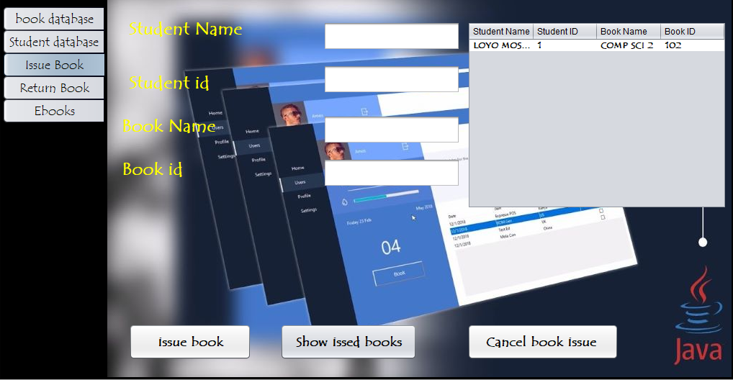

This frame shows how a staff member of the libraury can return books to libraury and the students’ details are captured in the database to show that the student returned the book.  
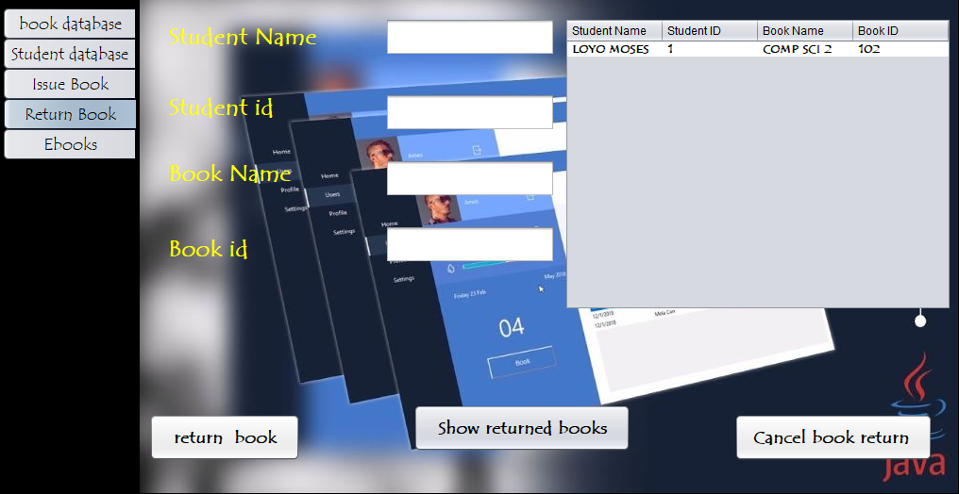

This frame shows how a staff member can access the eBooks which are manually added to the different folders for students to also access.  
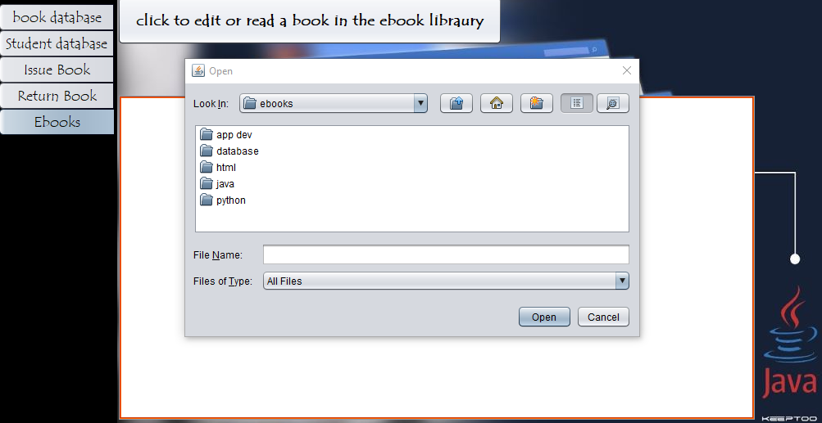

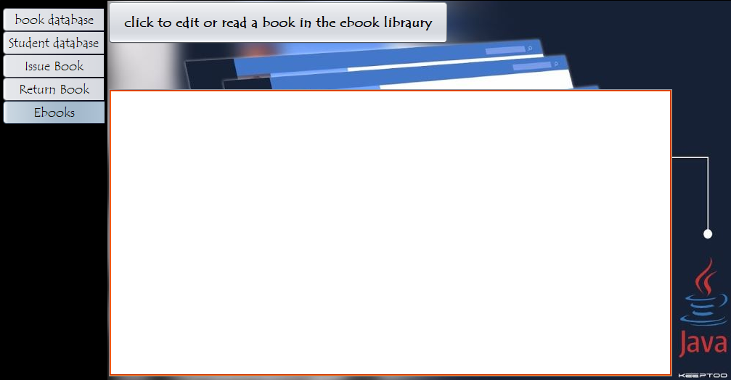

This is to choose the eBook’s to read and to show the ones that are in the folders.  


This is the login for students.  
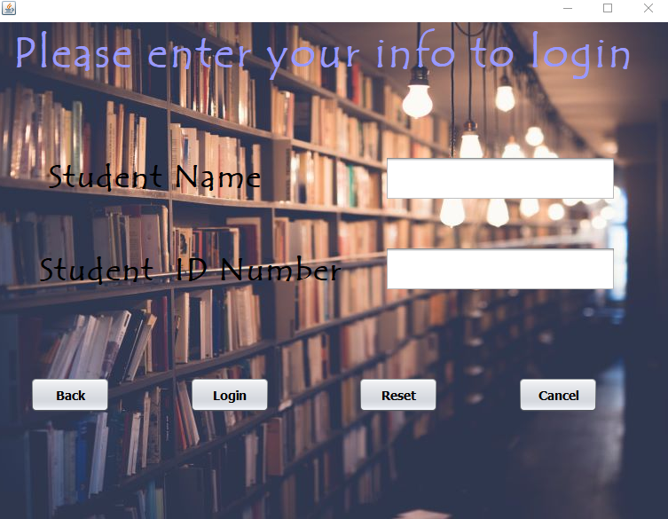

This is where a student can access online books specifically on pdfdrive.com and the student is not only limited to books but can research about anything here as shown below.

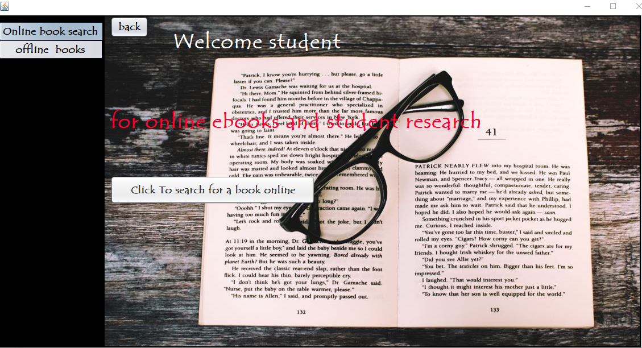

This is where a student can access offline eBooks on the computer specifically on and the student is not only limited to books but also lessons in the  
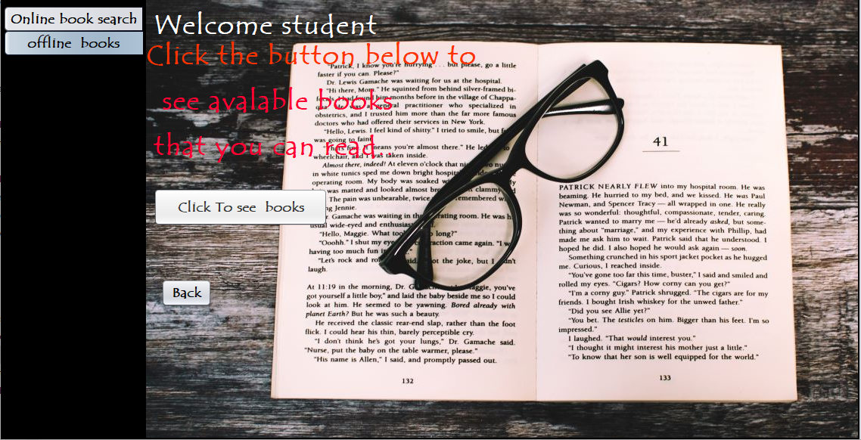

This frame shows the available eBooks provided by the libraury.  
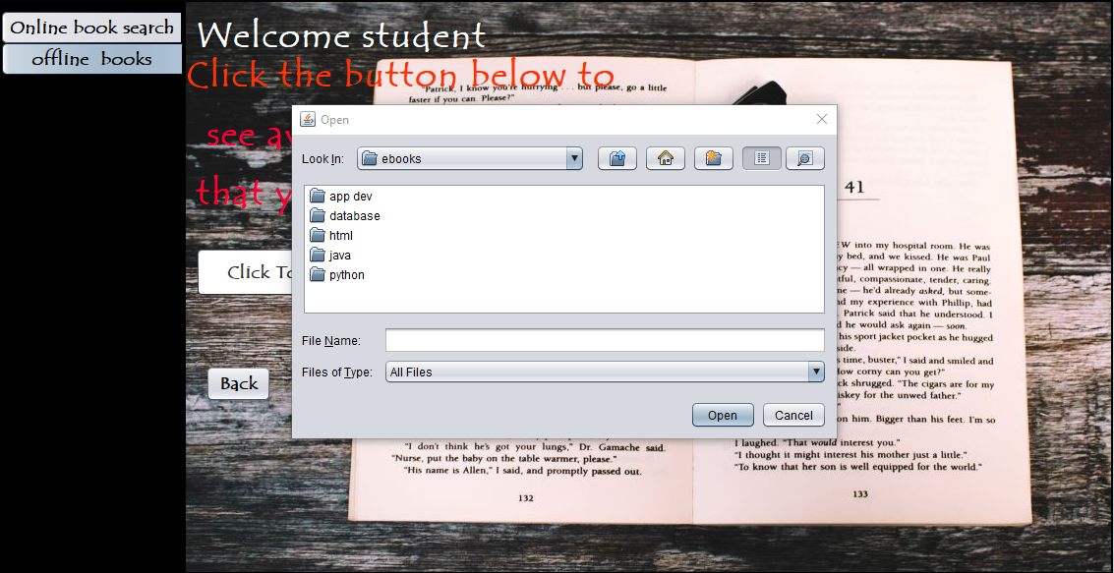

In conclusion this has been an amazing project to work on and I have learnt a lot and still are learning more as I continue to improve on this project. Thank you for the opportunity to challenge myself.